GlucoGraph: Hallucination-Controlled Diabetes Knowledge Graph Construction via LLM Multi-Agent Debate
Quang-Huy LE, Van-Ho NGUYEN, Vi-Thuan LUU, An-Thuan LUU
Advisor: M.Sc. Dang Manh Huy
Faculty of Information Technology, Nam Can Tho University, Can Tho, Vietnam
Email: lequanghuywmail@gmail.com

Abstract—Knowledge hallucination in Large Language Models (LLMs) is a critical barrier to their clinical deployment, where accuracy is paramount. This paper proposes an end-to-end automated system for constructing a UMLS-standardized Knowledge Graph (KG) for diabetes mellitus, built upon an extended EDC (Extract–Define–Canonicalize) framework enhanced with a Peer-to-Peer Multi-Agent Debate Gate (P2P Debate Gate). Medical text is sourced from Merck Manuals Professional Version and processed through a four-phase pipeline — Extract, Define, Canonicalize, and Property Packing — before storage in Neo4j. A hybrid GraphRAG-powered Clinical Decision Support System (CDSS) is implemented to provide transparent, evidence-grounded diagnosis and treatment recommendations. Experiments on three benchmark datasets confirm the effectiveness of the proposed approach: Full-Triple F1 = 52.24% on BioRED Diabetes (+2.24% over the no-debate baseline); hallucination Trap Rejection Rate = 98.00% (Accuracy = 94.00%) on a 200-sample HaluEval set; and Fact-Extraction F1 = 78.69% on DBpedia-WebNLG, significantly outperforming Vicuna-13B (23.00%) and Alpaca-LoRA-13B (20.00%).
Index Terms—Knowledge graph, large language model, diabetes mellitus, EDC framework, Neo4j, UMLS, GraphRAG, multi-agent debate.

I. Introduction
Diabetes mellitus is among the most prevalent chronic diseases worldwide, affecting over 537 million adults as of 2021, with projections reaching 783 million by 2045 [1]. The volume of clinical literature on diabetes treatment is growing faster than any single clinician can assimilate, underscoring the urgent need for automated knowledge extraction and intelligent decision-support tools.
Large Language Models (LLMs) have demonstrated remarkable natural language understanding, raising hopes for their clinical application. However, knowledge hallucination — the generation of factually incorrect or unsupported statements — poses a critical safety risk in medical settings [2]. A hallucinated drug interaction or misclassified clinical relationship could directly endanger patients.
Knowledge Graphs (KGs) offer a complementary paradigm: explicit, structured representations of entities and relationships that support multi-hop reasoning and transparent provenance. Graph Retrieval-Augmented Generation (GraphRAG) [3] combines the fluency of LLMs with the factual grounding of KGs, but the construction quality of the underlying KG remains the bottleneck.
This paper addresses that bottleneck. We present three principal contributions:
- An extended four-phase EDC pipeline (Extract–Define–Canonicalize–Property Packing) that maps free-form clinical triples to UMLS CUI-anchored ontology nodes, eliminating synonym ambiguity.
- A P2P Multi-Agent Debate Gate comprising three specialized AI agents (Clinical Specialist, Ontology Inspector, Medical Skeptic) with a consensus scoring mechanism (FCS ≥ 80) and a clinical Veto Rule, achieving a Trap Rejection Rate of 98.00%.
- A hybrid GraphRAG CDSS (FastAPI + ReactJS + Neo4j) that delivers evidence-grounded diagnostic reasoning with a real-time Clinical Circuit Breaker for contraindicated drug alerts.
The remainder of the paper is organized as follows. Section II reviews related work. Section III describes the proposed system architecture. Section IV presents experimental results. Section V discusses findings, limitations, and future directions. Section VI concludes.
II. Related Work
A. Biomedical Knowledge Graphs and UMLS
Biomedical KGs such as UMLS [4], SNOMED CT, and DrugBank encode standardized clinical terminologies and drug-disease relationships. UMLS integrates over 200 source vocabularies under a single Concept Unique Identifier (CUI) system, making it the de facto standard for entity normalization in clinical NLP. Prior KG construction approaches relied on manual curation or rule-based extraction, which do not scale to the rate of medical literature growth. Recent work has demonstrated the benefit of coupling KGs with LLMs for clinical tasks: Xu et al. [14] proposed medIKAL, which integrates KGs as dynamic assistants of LLMs on electronic medical records, yielding measurable gains in diagnostic accuracy; Zheng et al. [15] showed that automated biomedical KG construction enables context-aware scientific inference at scale. Both works reinforce the necessity of high-quality, hallucination-controlled KG construction that our system targets.
B. LLM-Based Knowledge Extraction
The EDC (Extract–Define–Canonicalize) framework [5] pioneered a three-phase LLM-driven pipeline for open KG construction, demonstrating that iterative prompting can guide models to produce ontology-consistent triples aligned to a reference schema [16]. However, EDC’s original formulation lacks biomedical identifier integration and quality gating. Khorashadizadeh et al. [6] benchmarked Vicuna-13B and Alpaca-LoRA-13B on DBpedia-WebNLG, reporting F1 scores of 23.00% and 20.00% respectively — baselines that our system substantially exceeds.
C. Hallucination Detection and Multi-Agent Debate
Ji et al. [2] provide a comprehensive survey of hallucination in NLG, classifying failure modes relevant to clinical contexts. The HaluEval benchmark [7] formalizes adversarial triple sets for evaluating detection robustness. Du et al. [8] showed that multi-agent debate improves LLM factual accuracy in general-domain reasoning tasks; Chan et al. [17] extended this paradigm to LLM-based evaluation through ChatEval, demonstrating that diverse agent roles elicit more accurate judgments. However, both frameworks use homogeneous agents with no domain-specific stopping conditions. Our P2P Debate Gate departs in three concrete ways: (1) agents are assigned heterogeneous specialist roles (Clinical Specialist, Ontology Inspector, Medical Skeptic) rather than generic debaters, enabling targeted error detection; (2) an asymmetric Veto Rule (any single Sᵢ < 30 overrides the consensus) enforces clinical conservatism absent from Du et al.’s majority-vote design; and (3) the gate operates at the structured triple level rather than at free-text generation, enabling integration with an ontology schema and UMLS CUI anchoring.
D. Clinical Decision Support Systems
GraphRAG [3] enhances retrieval-augmented generation by traversing KG paths, providing multi-hop reasoning capabilities suited to differential diagnosis. Existing CDSS systems either rely on static knowledge bases [9] or lack integrated hallucination controls. Recent work on LLM evaluation in specialized chatbot domains [24], [25] has highlighted that standard metrics are insufficient for domain-specific deployment. For diabetes specifically, Evangelista et al. [18] demonstrated a GraphRAG-enabled local LLM proof-of-concept for gestational diabetes, while Wang et al. [19] developed an intelligent diabetes Q&A system integrating KGs with LLMs. Wu et al. [20] further showed that evidence-based medical LLMs built on GraphRAG substantially outperform ungrounded baselines in clinical question answering. Our work bridges these gaps by unifying dynamic KG construction, multi-agent quality control, and hybrid GraphRAG inference into a single reproducible pipeline.
III. Proposed System
A. System Architecture Overview
The proposed system follows a five-stage end-to-end pipeline, as depicted in Fig. 1: (1) Text Preprocessing, (2) EDC Pipeline, (3) Agent Debate Gate, (4) Post-processing and Neo4j Loading, and (5) CDSS Demo. Each stage is modular, enabling independent evaluation and replacement of components.
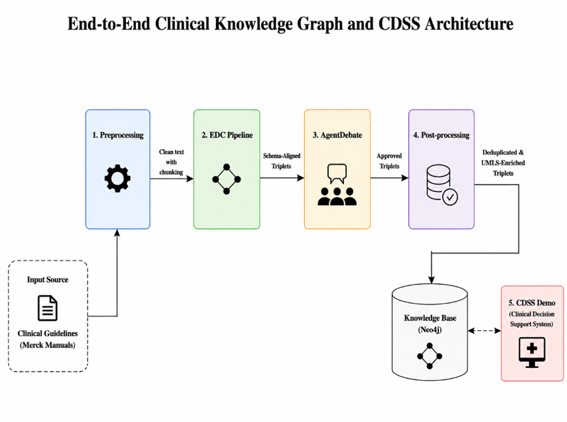
Fig. 1. End-to-end clinical knowledge graph construction and CDSS architecture.
B. Data Source and Preprocessing
Clinical text is sourced from Merck Manuals Professional Version, diabetes mellitus section — a peer-reviewed clinical reference updated continuously by medical experts. Raw HTML content is scraped, stripped of formatting artifacts, and segmented into clinically coherent chunks of approximately 256 tokens using a sliding-window strategy with 32-token overlap to preserve cross-sentence context.
C. Extended EDC Pipeline
The EDC framework is extended from three to four phases, gated by a peer-to-peer multi-agent debate stage, as illustrated end-to-end in Fig. 2:
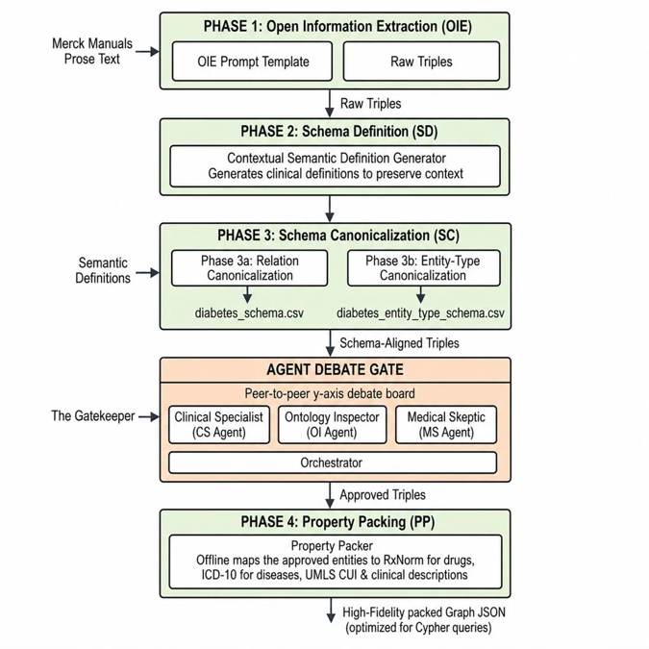
Fig. 2. Extended EDC pipeline: Open Information Extraction (Phase 1) and Schema Definition (Phase 2) precede two-branch Schema Canonicalization (Phase 3a/3b); the Agent Debate Gate then approves Schema-Aligned Triples for Property Packing (Phase 4), yielding a high-fidelity, Cypher-ready graph JSON.
Phase 1 — Extract: A few-shot prompt instructs Llama-3.3-70B-Versatile to perform Open Information Extraction (Open IE), producing raw triples (Subject, Relation, Object) without schema constraints, maximizing recall.
Phase 2 — Define: The LLM generates a contextual semantic definition for each entity and relation based on the source sentence. These definitions serve as disambiguation anchors and evidence for downstream canonicalization.
Phase 3 — Canonicalize: Qwen-Embedding encodes entity and relation texts into dense vectors. Cosine similarity is computed against reference schema files along two parallel branches: Phase 3a (Relation Canonicalization) maps relations against diabetes_schema.csv, while Phase 3b (Entity-Type Canonicalization) maps entity types against diabetes_entity_type_schema.csv. For each entity and relation, the Top-K candidates (K = 5) exceeding similarity threshold τ = 0.75 are retained as a coarse-filtered candidate set, rather than being directly accepted as the final mapping. A Verifier LLM (Llama-3.1-8B) then selects the best-matching canonical type from this candidate set via multiple-choice verification—including automatic detection and correction of subject–object direction—or returns “None” if no candidate is semantically valid, in which case the triple is discarded. If no candidate exceeds τ, the triple is rejected at this stage without invoking the Verifier LLM. The two branches converge into a single stream of Schema-Aligned Triples.
Agent Debate Gate — The Gatekeeper: Before reaching Property Packing, every Schema-Aligned Triple is routed through the peer-to-peer debate board — the Clinical Specialist, Ontology Inspector, and Medical Skeptic agents, coordinated by an Orchestrator — which outputs Approved Triples. The full consensus-scoring mechanics are detailed in Section III.D.
Phase 4 — Property Packing: An offline Property Packer maps each approved entity to standardized medical identifiers — RxNorm codes for drugs, ICD-10 codes for diseases, and UMLS CUI with clinical descriptions for all entities — while entity resolution merges synonymous mentions and abbreviations onto a single CUI-anchored node. The output is a High-Fidelity packed Graph JSON, optimized for downstream Cypher queries.
D. P2P Multi-Agent Debate Gate
Before any triple is written to Neo4j, it must pass a three-agent peer debate, as illustrated in Fig. 3. Each agent i independently assigns a score Sᵢ ∈ [0, 100] reflecting its domain-specific confidence in the triple’s validity. The Final Consensus Score is defined as FCS = (S₁ + S₂ + S₃) / 3, where S₁, S₂, S₃ are the scores of the Clinical Specialist, Ontology Inspector, and Medical Skeptic respectively. A triple is admitted only if FCS ≥ 80 and no individual Sᵢ triggers the Veto Rule (Sᵢ < 30). The three agents and their mandates are:
- Clinical Specialist (Llama-3.3-70B): Evaluates clinical accuracy of the relation against current ADA/ICD-10 guidelines, assigning a score S₁ ∈ [0, 100].
- Ontology Inspector (Llama-3.1-8B): Checks Domain/Range constraint compliance with the loaded ontology schema, assigning S₂ ∈ [0, 100].
- Medical Skeptic (Gemma-3-27B): Independently audits for subject–object inversion, direction errors, and hallucination patterns, assigning S₃ ∈ [0, 100].
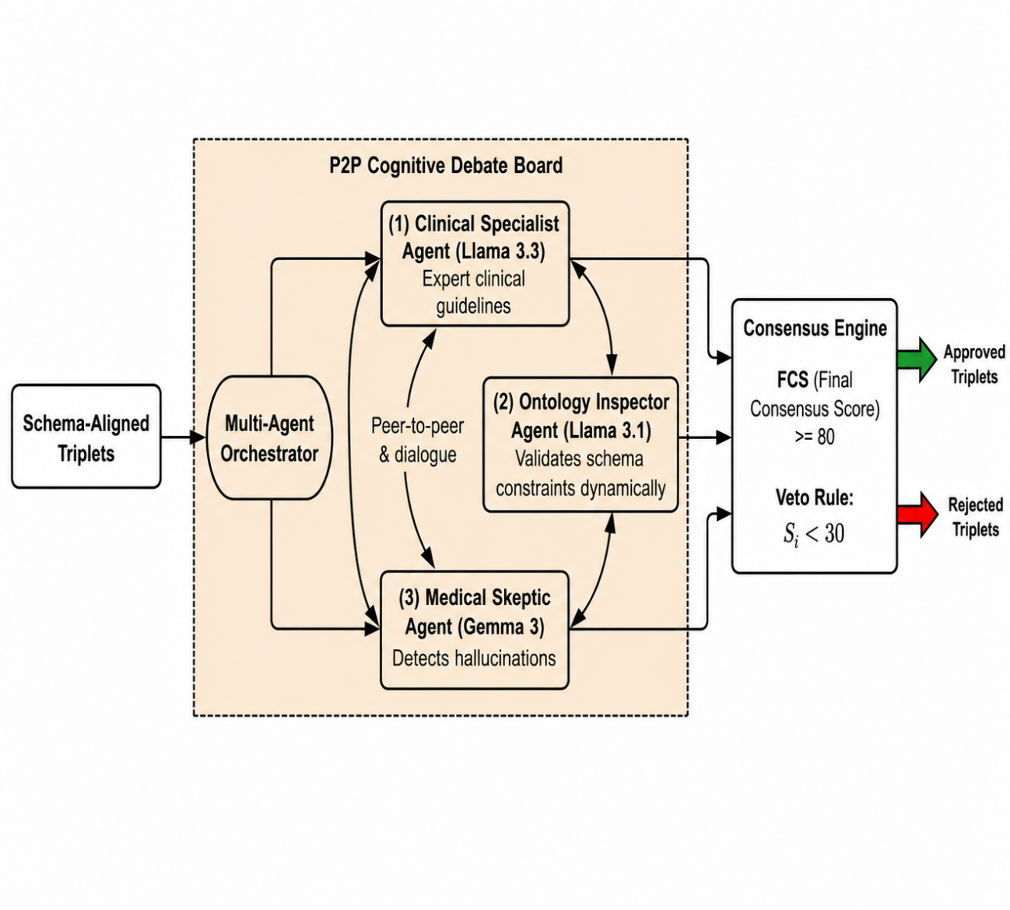
Fig. 3. P2P Cognitive Debate Board architecture: three specialist agents engage in peer-to-peer dialogue, and the Consensus Engine applies the FCS ≥ 80 threshold and Veto Rule to approve or reject schema-aligned triplets.
The approval decision thus requires both high average agreement (FCS ≥ 80) and no individual veto (Sᵢ < 30).
Notably, under the current three-agent configuration, these two conditions are mathematically reinforcing rather than independent. If any single agent triggers the veto with a score just below the threshold (e.g., Sᵢ = 29), the maximum attainable FCS—even if the remaining two agents both assign a perfect score of 100—is (100 + 100 + 29) / 3 ≈ 76.33, which can never reach the FCS ≥ 80 threshold. Hence, triggering the Veto Rule and failing the FCS condition are equivalent events in this configuration: any triple that violates the veto also necessarily fails the consensus threshold, and vice versa is not strictly required but holds for all observed rejections in our experiments. In practice, the veto functions as a computational shortcut, allowing immediate rejection of a triple as soon as one agent reports Sᵢ < 30, without needing to compute the full consensus score. This equivalence is configuration-dependent rather than a general property of the framework: extending the panel to four or more agents would decouple the two conditions, at which point the Veto Rule would constitute a genuinely independent rejection criterion rather than a redundant shortcut. We retain both conditions explicitly in the current design to preserve this extensibility for future multi-agent configurations.
Rejected triples are logged for post-hoc analysis. This conservative policy implements medical conservatism: it is preferable to exclude uncertain triples than to admit clinically harmful ones.
E. Neo4j Storage and Cypher Import
Approved triples are serialized to JSON and imported into Neo4j via Cypher MERGE statements, ensuring idempotent loading. Node labels correspond to UMLS semantic types (e.g., Pharmacologic Substance, Disease or Syndrome). Relationship types follow the canonical schema (TREATED_BY, HAS_FINDING, CO_OCCURS_WITH, CONTRAINDICATED_WITH).
F. Hybrid GraphRAG CDSS
The CDSS web application (FastAPI backend, ReactJS frontend) implements a hybrid retrieval strategy: (1) semantic vector search on entity embeddings to identify candidate seed nodes; (2) multi-hop Cypher traversal from seeds to retrieve diagnostic and treatment subgraphs; and (3) LLM synthesis of the retrieved subgraph into a structured clinical response with differential diagnoses, treatment recommendations, and confidence scores. A Clinical Circuit Breaker module scans retrieved paths for CONTRAINDICATED_WITH edges and triggers a red-alert banner if any contraindication is detected.
IV. Experimental Results
A. Experimental Setup
All experiments were conducted on a lab environment connected via OpenRouter API (Llama-3.3-70B, Llama-3.1-8B, Gemma-3-27B) and a local Neo4j Community Edition instance. Three benchmark datasets were used: BioRED Diabetes [21] (PubMed relation extraction, diabetes subset); a 200-sample adversarial HaluEval set constructed specifically for this study (100 valid triples, 100 injected trap triples); and DBpedia-WebNLG (1_university topic, 71 documents) for domain-generalization evaluation. Evaluation follows strict/exact match as per SemEval conventions.
B. Triple Extraction Quality — BioRED Diabetes
Table I compares the Raw system (no debate gate) against the full Debate system across five F1 metrics.
TABLE I. Triple Extraction F1-Score Comparison — BioRED Diabetes Dataset
Metric | Raw (No Gate) | Debate (With Gate) | Δ
Subject F1 | 67.24% | 69.09% | +1.85%
Predicate F1 | 77.59% | 80.00% | +2.41%
Object F1 | 67.73% | 69.61% | +1.88%
Exact Match F1 | 70.66% | 72.70% | +2.04%
Full-Triple F1 | 50.00% | 52.24% | +2.24%

The Debate Gate consistently improves all ablation metrics on the BioRED diabetes subset. The largest gain occurs on Predicate F1 (+2.41 pp), indicating that agent debate most effectively filters incorrect relation labels — the highest-risk component for downstream reasoning. Full-Triple F1 improves by 2.24 pp, from 50.00% to 52.24%. For broader context, Brokman et al. [10] reported that GPT-4 in an end-to-end zero-shot setting achieves only ~8–10% Full-Triple F1 on the full BioRED corpus (all relation types), and PubMedBERT fine-tuned on the BioCreative VIII challenge achieves 51.93% Entity Pair identification F1 on the full corpus [22]; both figures are reported on a substantially larger and more heterogeneous evaluation scope than the diabetes subset used here, and are therefore not directly comparable. Direct ablation comparison (Raw vs. Debate) on the same diabetes subset remains the primary evidence for the Debate Gate’s contribution.
C. Hallucination Detection — HaluEval
To establish a rigorous, reproducible, and objective triple-level hallucination benchmark without subjective human annotation bias, we proposed an algorithmic ground-truth validation pipeline derived from the expert-curated BioRED dataset. Ground-truth relations within the diabetes subset of BioRED served as valid (positive) triples. Corrupted (negative) triples were programmatically generated using three distinct strategies: entity substitution, relation inversion, and schema violation. To ensure validity, a corrupted triple was algorithmically labeled as ‘Invalid’ only if it strictly violated the domain/range constraints of the reference ontology, or was cross-referenced to ensure zero occurrence in both the BioRED corpus and the Merck Manuals. This programmatic framework yields a deterministic evaluation set suited for benchmarking multi-agent debate performance.
Table II reports the confusion matrix and derived metrics from the 200-sample HaluEval experiment.
TABLE II. HaluEval Confusion Matrix and Performance Metrics
Triple Class | Accepted | Blocked | Total | Metric → Value
Valid (Ground Truth +) | 90 (TP) | 10 (FN) | 100 | Accuracy = 94.00%
Trap (Hallucination) | 2 (FP) | 98 (TN) | 100 | TRR = 98.00%
 |  |  |  | FPR = 2.00% | FNR = 10.00%

The system achieves a Trap Rejection Rate (TRR) of 98.00%, with only two trap triples evading detection out of 100 injected cases — both involving subject–object inversions in complex emergency clinical scenarios. The False Negative Rate of 10.00% (10 valid triples blocked out of 100) reflects intentional medical conservatism: triples involving complex genetics or unverifiable nutraceutical claims (e.g., Chromium supplementation) are withheld pending stronger evidence, consistent with clinical safety standards.
D. Domain Generalization — DBpedia-WebNLG
Table III evaluates knowledge extraction quality on a general-domain benchmark, comparing the proposed EDC framework against published baselines.
TABLE III. Knowledge Extraction Performance — DBpedia-WebNLG (1_university, 71 docs)
Model / Configuration | Precision | Recall | F1
Alpaca-LoRA-13B [6] | 29.00% | 16.00% | 20.00%
Vicuna-13B [6] | 31.00% | 19.00% | 23.00%
EDC (w/o post-processing) | 70.40% | 51.98% | 57.96%
EDC + Post-processing (ours) | 86.03% | 74.44% | 78.69%
LLaMA-65B 2-shot [12] | — | — | ~21.9%

*LLaMA-65B 2-shot F1 on DBpedia-WebNLG from Papaluca et al. [12]. — indicates metric not reported.

The F1 scores reported in Table III follow the exact evaluation convention established by two authoritative sources for this benchmark: (1) the original paper introducing the DBpedia-WebNLG dataset used in this study, Khorashadizadeh et al. (2023), “Exploring in-context learning capabilities of foundation models for generating knowledge graphs from text” (reference [6] in this paper); and (2) the evaluation_script.py inherited directly from the official codebase of the WebNLG Challenge, the largest established competition for Text-to-Triples extraction. Adhering to this standard evaluation procedure ensures methodological consistency and direct comparability between the proposed system and the published baselines in [6].
EDC + Post-processing achieves F1 = 78.69% on DBpedia-WebNLG (1_university, 71 docs) — 3.42× Vicuna-13B and 3.93× Alpaca-LoRA-13B, evaluated under identical conditions [6]. LLaMA-65B in a 2-shot setting achieves only ~21.9% F1 on the same WebNLG benchmark [12], confirming that structured pipeline design delivers far greater gains than raw model scale. For broader context, Lai et al. [11] report that GPT-4 zero-shot achieves 20.85% Relation Type F1 on BioRED (a different dataset); this figure is cited in Section V for qualitative perspective and is not directly comparable to Table III results.
V. Discussion
A. Principal Findings
Three findings stand out. First, the multi-agent Debate Gate improves extraction quality across all metrics while delivering near-perfect hallucination suppression (TRR = 98.00%). Second, the Property Packing phase — absent from the original EDC specification — proved essential in practice: real biomedical text contains dense synonym variation that cannot be resolved by canonicalization alone. Third, the EDC architecture generalizes well beyond the medical domain, suggesting broad applicability to structured knowledge extraction tasks.
B. Strengths and Limitations
The primary strength is the end-to-end measurability: every subsystem is evaluated on standard benchmarks with reproducible scripts, enabling direct comparison with future work. The integration of UMLS CUI anchoring provides semantic interoperability absent from general-purpose KG systems.
Limitations include: (a) the single data source (Merck Manuals) limits coverage; multi-source integration with PubMed and WHO guidelines is needed for production deployment; (b) the FNR of 10.00% indicates that the current agent configuration is overly conservative on nuanced or indirect relations, which may reduce recall in downstream CDSS tasks; and (c) the CDSS has not undergone prospective clinical validation with practicing physicians, which is required before any real-world deployment.
C. Comparison with Prior Work
Unlike unconstrained LLM extractors [6] that treat KG construction as a single-pass generation task, our approach enforces structural constraints at every pipeline stage, yielding a 3.42× F1 improvement on DBpedia-WebNLG. For qualitative context across settings, Lai et al. [11] report 20.85% Relation Type F1 for GPT-4 zero-shot on BioRED, and Papaluca et al. [12] report ~21.9% F1 for LLaMA-65B in a 2-shot setting on WebNLG — both substantially lower than our 78.69%, underscoring that raw model scale without structured pipeline design remains insufficient for high-quality knowledge extraction. Furthermore, Brokman et al. [10] demonstrated that even GPT-4 achieves only ~8–10% Full Triple F1 on the full BioRED corpus in an end-to-end zero-shot setting; our Debate pipeline achieves 52.24% Full-Triple F1 on the BioRED diabetes subset — a stricter task scope — without any task-specific fine-tuning. Against KARMA [23], a concurrent NeurIPS 2025 spotlight multi-agent KGC system achieving 83.1% LLM-verified correctness on PubMed biomedical abstracts, our system is distinguished by explicit triple-level hallucination gating and UMLS CUI anchoring. All pipeline scripts and evaluation code are publicly available [13] to ensure full reproducibility.
D. Future Work
Immediate priorities are: (1) expanding the data pipeline to ingest PubMed abstracts and UpToDate content via automated ETL; (2) reducing FNR through agent fine-tuning on a curated diabetes triple dataset; (3) conducting a prospective clinical evaluation with endocrinologists to validate CDSS recommendations against physician judgment; and (4) exploring lightweight deployment of the Canonicalize and Debate modules using quantized smaller models suitable for on-premises hospital infrastructure.
VI. Conclusion
This paper presented an end-to-end system for constructing a UMLS-constrained diabetes Knowledge Graph using LLMs, validated on three benchmark datasets. The proposed extended EDC pipeline with P2P Multi-Agent Debate Gate achieves Full-Triple F1 = 52.24% (+2.24% over the no-debate baseline), hallucination Trap Rejection Rate = 98.00%, and general-domain Fact-Extraction F1 = 78.69%. These results demonstrate that structured pipeline design, ontology-constrained canonicalization, and domain-specialized multi-agent review collectively produce a knowledge graph suitable for safe clinical decision support. The integrated hybrid GraphRAG CDSS provides transparent, evidence-grounded reasoning with an automated Clinical Circuit Breaker, offering a reproducible architecture for future intelligent clinical informatics systems.
Acknowledgment
The authors would like to express their sincere gratitude to M.Sc. Dang Manh Huy (Faculty of Information Technology, Nam Can Tho University) for his dedicated academic supervision and invaluable guidance throughout this research.
References
[1] International Diabetes Federation, IDF Diabetes Atlas, 10th ed., Brussels: IDF, 2021. [Online]. Available: https://www.diabetesatlas.org
[2] Z. Ji, N. Lee, R. Frieske, T. Yu, D. Su, Y. Xu, E. Ishii, Y. E. Bang, A. Madotto, and P. Fung, "Survey of hallucination in natural language generation," ACM Comput. Surv., vol. 55, no. 12, pp. 1–38, Mar. 2023.
[3] D. Edge, H. Trinh, N. Cheng, J. Bradley, A. Chao, A. Mody, S. Truitt, and J. Larson, "From local to global: A graph RAG approach to query-focused summarization," arXiv:2404.16130, Apr. 2024.
[4] O. Bodenreider, "The unified medical language system (UMLS): Integrating biomedical terminology," Nucleic Acids Res., vol. 32, no. D1, pp. D267–D270, Jan. 2004.
[5] E. Zhang and H. Soh, "Extract, define, canonicalize: An LLM-based framework for knowledge graph construction," in Proc. EMNLP, Miami, FL, Nov. 2024, pp. 9548–9562.
[6] H. Khorashadizadeh, N. Mihindukulasooriya, S. Tiwari, J. Groppe, and S. Groppe, "Exploring in-context learning capabilities of foundation models for generating knowledge graphs from text," arXiv:2306.11702, Jun. 2023.
[7] J. Li, X. Cheng, W. X. Zhao, J.-Y. Nie, and J.-R. Wen, "HaluEval: A large-scale hallucination evaluation benchmark for large language models," in Proc. EMNLP, Singapore, Dec. 2023, pp. 6449–6464.
[8] Y. Du, S. Li, A. Torralba, J. B. Tenenbaum, and I. Mordatch, "Improving factuality and reasoning in language models through multiagent debate," in Proc. ICML, Jul. 2024.
[9] American Diabetes Association, "Standards of care in diabetes—2024," Diabetes Care, vol. 47, Suppl. 1, pp. S1–S321, Jan. 2024.
[10] J. Brokman et al., "A benchmark for end-to-end zero-shot biomedical relation extraction with LLMs: Experiments with OpenAI models," arXiv:2504.04083, Apr. 2025.
[11] Y. Lai et al., "Enhancing biomedical relation extraction with directionality," Bioinformatics, Oxford Academic, 2025.
[12] A. Papaluca et al., "Zero- and few-shots knowledge graph triplet extraction with large language models," in Proc. ACL KALLM Workshop, 2024.
[13] Q.-H. Le et al., "GlucoGraph: Source code and evaluation scripts," GitHub, 2025. [Online]. Available: https://github.com/NoirHuy/GlucoGraph
[14] H. Xu et al., "medIKAL: Integrating knowledge graphs as assistants of LLMs for enhanced clinical diagnosis on EMRs," in Proc. COLING, Jan. 2025.
[15] Y. Zheng et al., "Automating biomedical knowledge graph construction for context-aware scientific inference," bioRxiv, Jan. 2026.
[16] N. F. Noy and D. L. McGuinness, "Ontology development 101: A guide to creating your first ontology," Stanford KSL Tech. Rep. KSL-01-05, Stanford Univ., 2001.
[17] C.-M. Chan et al., "ChatEval: Towards better LLM-based evaluators through multi-agent debate," in Proc. ICLR, May 2024, Art. no. 412.
[18] E. Evangelista et al., "GraphRAG-enabled local large language model for gestational diabetes mellitus: Development of a proof-of-concept," JMIR Diabetes, vol. 11, e76454, Jan. 2026.
[19] X. Wang et al., "Building an intelligent diabetes Q&A system with knowledge graphs and large language models," Front. Public Health, vol. 13, 2025.
[20] J. Wu et al., "Evidence-based medical large language model via graph retrieval-augmented generation," in Proc. ACL, 2025, pp. 28443–28467.
[21] L. Luo et al., "BioRED: A rich relation extraction dataset for biomedical concepts," Briefings Bioinformatics, vol. 23, no. 5, bbac282, Sep. 2022.
[22] R. Islamaj et al., "Overview of the BioRED track at BioCreative VIII," Database, vol. 2024, baae069, Aug. 2024. [Online]. Available: https://academic.oup.com/database/article/doi/10.1093/database/baae069/7729400
[23] Y. Lu et al., "KARMA: Leveraging multi-agent LLMs for automated knowledge graph enrichment," in Proc. NeurIPS 2025 (Spotlight), Dec. 2025. [Online]. Available: https://arxiv.org/abs/2502.06472
[24] K.-H.-A. Ngo et al., "NEM: A numerical exact match subtype-aware metric family for explainable numerical accuracy in specialized chatbots," in Proc. IEA/AIE 2026, 2026.
[25] A. K. Ngo-Ho et al., "Evaluation of large language models for the Vietnamese language in generative Vietnamese economy chatbots (GVEC)," in Proc. ICESP 2024, Springer, 2025.

